CLAIM REQUEST
CLIENT REFERENCE:
URL : https://web2ess.elitehrms.com
User Name : DC0003
Password : M@ster
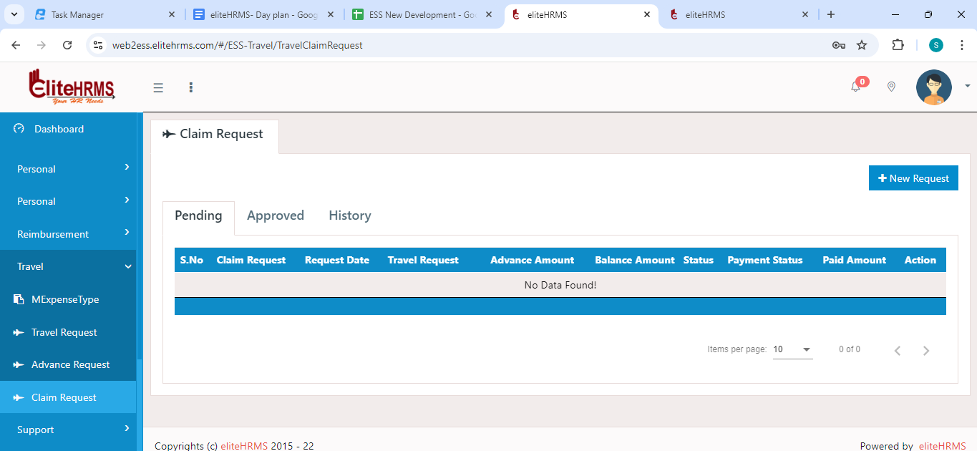

- First page need to change the search page.
- In edit mode to call “GetClaim”
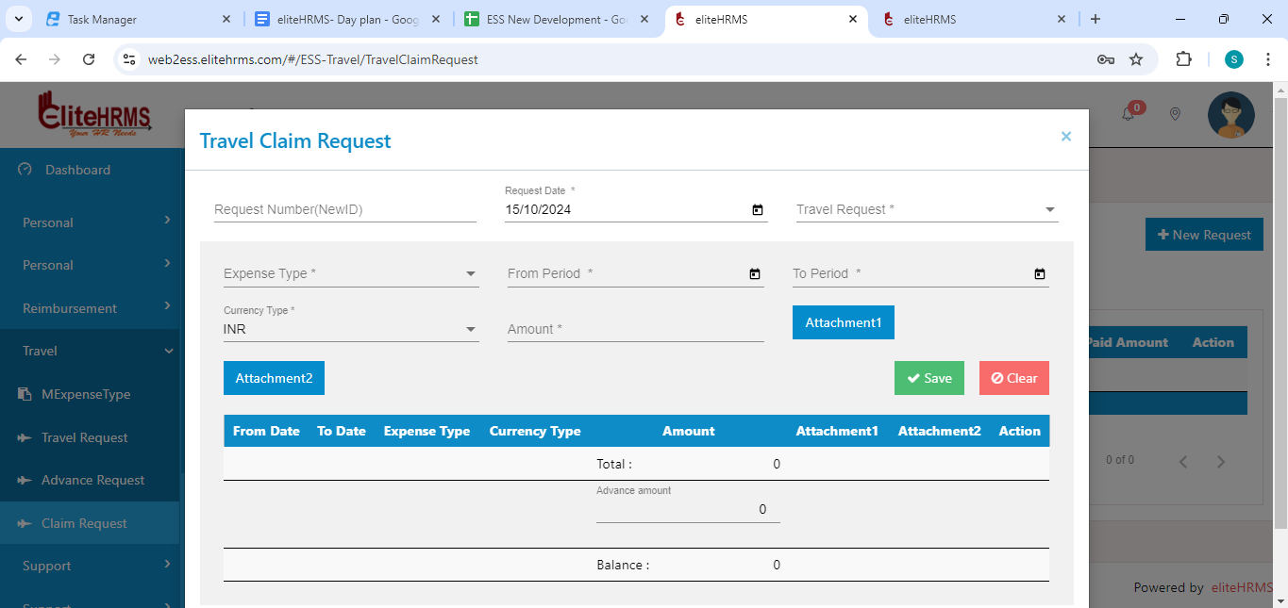
- Expense type dropdown reference – AdvanceExpenseType
- Currency Type dropdown reference – CurrencyCode
- Travel Request dropdown reference – Travelrequest
- After entered the all data to call “PostRequisition”
- In Json “RequisitionType” – need to send default 2 in Advance request.
Post Api :
https://localhost:44349/api/Travel/PostRequisition
{
"Requisitionguid": null,
"RequestNo": null,
"RequestDate": "2024-10-14",
"TravelRequestguid": "41A6EBE9-EB51-4C8D-AC16-F935EE592166",
"TotalAmount": 20000,
"AdvanceAmount": 0,
"BalanceAmount": 20000,
"RequisitionType": "2",
"ScreenID": 1554,
"RequisitionChild": [
{
"ExpensetypeID": "DF34FF48-69E8-4ED6-BB87-AC0B08C3442D",
"CurrencyTypeID": "1",
"Amount": 20000,
"FromPeriod": "2024-10-14",
"ToPeriod": "2024-10-15",
"Attachment1": null,
"Attachment2": null
}
]
}
{
"Response": {
"_status": "Success",
"_code": "111",
"_Source": "PostRequisition",
"_Description": "Inserted Successfully...",
"_Details": "Workflow screen not added",
"_TransID": null,
"_Timestamp": "20241015132522"
},
"RequestNo": null,
"Requisitionguid": null,
"RequestDate": null,
"TravelRequestguid": null,
"TotalAmount": null,
"AdvanceAmount": null,
"BalanceAmount": null,
"RequisitionType": null,
"TravelRequest": null,
"ClaimStatus": null,
"ScreenID": 0,
"Paymentstatus": null,
"Paidamount": null,
"RequisitionChild": []
}

GET API :
https://localhost:44349/api/Travel/GetClaim?Requisitionguid=683FB782-567F-4853-9388-3D810E712DCE
{
"Response": {
"_status": "Success",
"_code": "111",
"_Source": "GetClaim",
"_Description": "Success",
"_Details": "",
"_TransID": null,
"_Timestamp": "20241015133035"
},
"RequisitionDetails": [
{
"Response": null,
"RequestNo": "TVR/24-25/00002",
"Requisitionguid": "683fb782-567f-4853-9388-3d810e712dce",
"RequestDate": "14/10/2024",
"TravelRequestguid": "41a6ebe9-eb51-4c8d-ac16-f935ee592166",
"TotalAmount": null,
"AdvanceAmount": "0.00",
"BalanceAmount": "20000.00",
"RequisitionType": null,
"TravelRequest": "TRQ/24-25/00001",
"ClaimStatus": "6862",
"ScreenID": 0,
"Paymentstatus": "",
"Paidamount": "",
"RequisitionChild": []
}
]
}

